Guidelines for Paper Presentations at NAMRC 45/MSEC 2017/ICMP 2017
- The presentation rooms will be equipped with a computer to display your presentation. The presenters can also use their own laptops to present papers.
- Each room will be equipped with a projector. The projector will have the VGA connector pictured below. If you have a Mac, you need to bring a Mini-Display Port adaptor to connect to the VGA connector. If you require a different adaptor for your device to connect to the VGA, you must bring it with you.
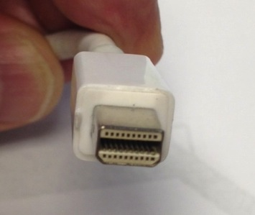
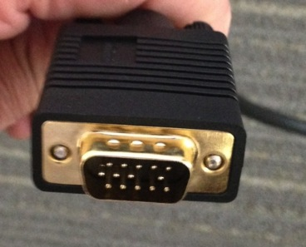

VGA Connector Mini DisplayPort Adaptor
- Arrive 15 min before the session starts and test your computer connection. Make sure all videos, animations, and other special effects operate properly.
- Introduce yourself to the session chair.
- Prepare and practice your presentation.
- Each presenter will have 30 minutes. Plan to finish your presentation in about 20-25 min and leave 5-10 min for Q&A.

